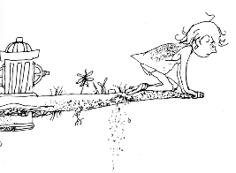
Where the Sidewalk Ends
from the book "Where the Sidewalk Ends" (1974)
There is a place where the sidewalk ends
and before the street begins,
and there the grass grows soft and white,
and there the sun burns crimson bright,
and there the moon-bird rests from his flight
to cool in the peppermint wind.
Let us leave this place where the smoke blows black
and the dark street winds and bends.
Past the pits where the asphalt flowers grow
we shall walk with a walk that is measured and slow
and watch where the chalk-white arrows go
to the place where the sidewalk ends.
Yes we'll walk with a walk that is measured and slow,
and we'll go where the chalk-white arrows go,
for the children, they mark, and the children, they know,
the place where the sidewalk ends.
CONSTRUCTED RESPONSE QUESTION: THE OREO METHOD
1. How does the use of archetypes in the poem help to develop the theme?
Topic Sentence (The Cookie)

Two Supporting Details (Double Stuffed Filling)

Closure (Bottom of the Cookie)

